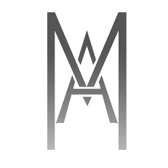
Date:10 may 2018
Thank you
Dear [Guest Name],
Thank you for choosing [Hotel Name] for your recent stay in [Location]! Could you please take a moment to fill out our Guest Survey?
We Love to hear your feedback and use it to review and improve our services every day!
Come back soon and remember to use our exclusive return guest offer from our website [mahotels.net] using Promo code[THANKYOU].
Looking forward to welcome you again soon.

[Hotel Manager Name and Sign]

General Manager
T: +966 599999999
E: info@mahotels.net

